The morticing jig (without the router in place)

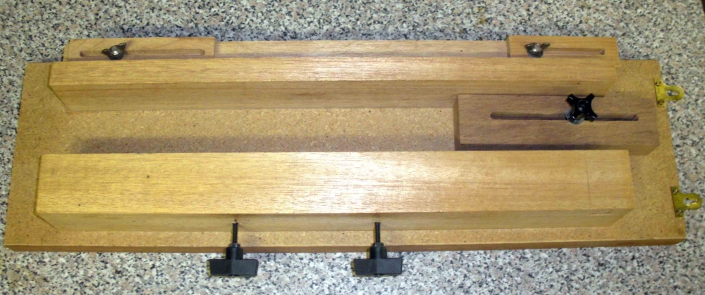

At the bottom (foreground) are two handles which are threaded through the (lower) jig side beam. On the other side is a nut which acts as a bearing against the workpiece (or a spacer) to hold the workpiece in place. On the right of the picture, between the two beams, is a sliding stop for positioning the leg to be morticed. At the top of the picture the two sliding stops, which limit the travel of the carriage (from left to right) can be seen.

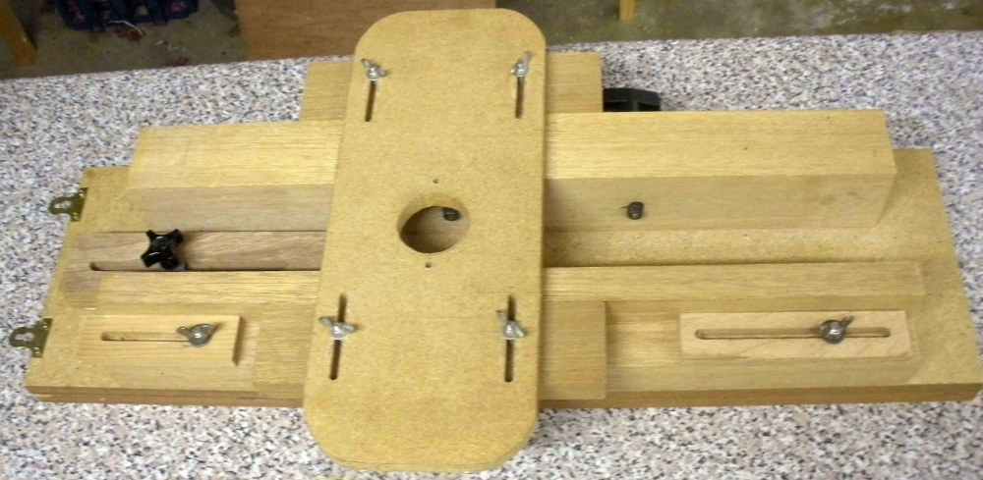

In front, at each end, are two sliding stops to limit the carriage travel from left to right (this then determines the length of the mortice). The carriage is held in place by two blocks over the sides of the main beams - the butterfly nuts allow for positioning the mortice on one side of the leg or the other.

The two nuts, adjusted by the handles on the far side (one can be seen through the router hole), act as bearings against the workpiece or a spacer block to clamp the workpiece in position. On the left a black plastic handle is used to set the position of the sliding stop (inside the two beams) to position the workpiece (here, from left to right) and in conjunction with the front sliding stops, set the position of the mortice.
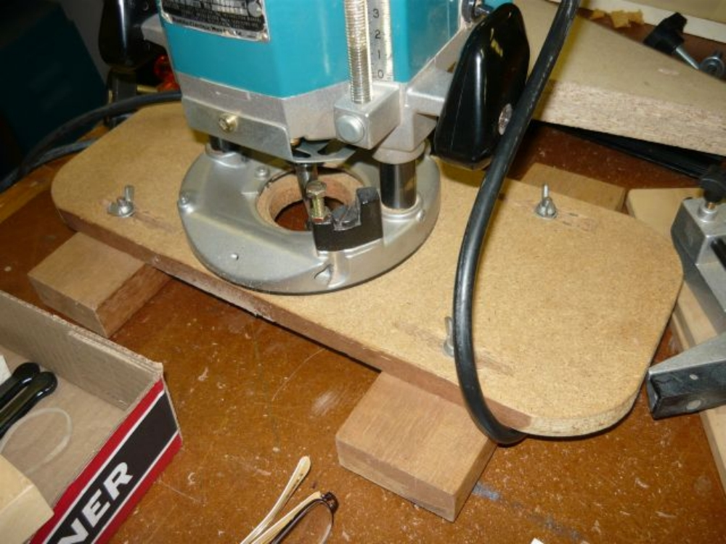
A router mounted on the sliding carriage of the mortising jig. The carriage slides while the router
is plunged into the workpiece.

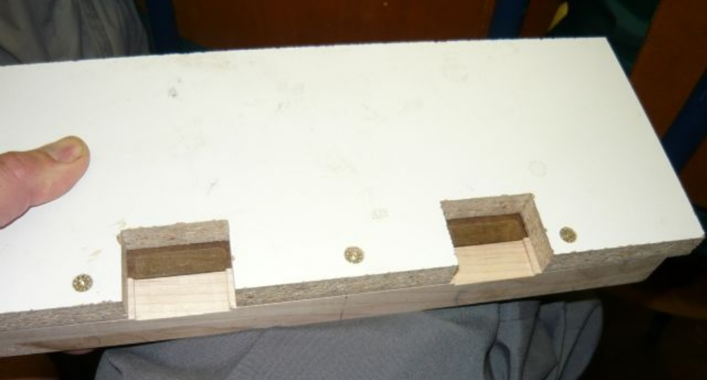

The double hinge mortising jig I made to do the hinges on my small boxes. This ensures that
the mortises cut on the top and on the box side register exactly.

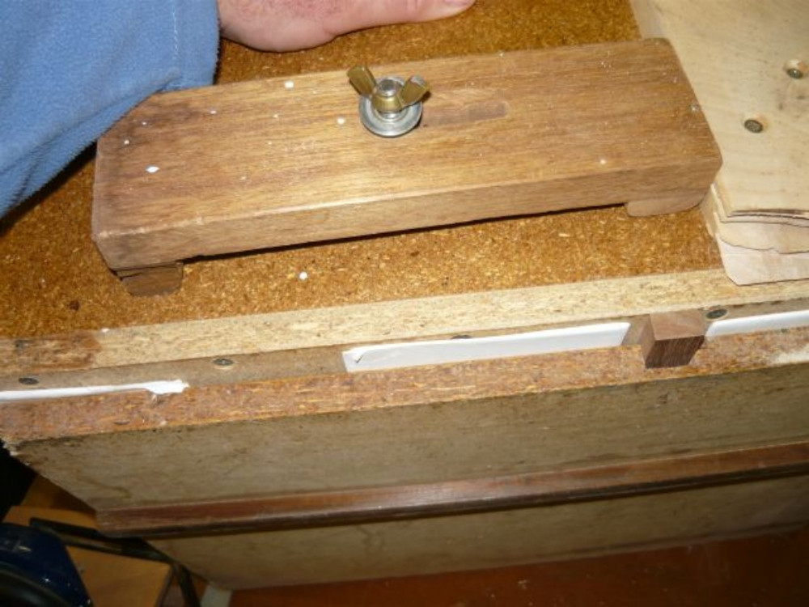

A funny view (taken from below) of the tenoning jig made for the tablesaw that I sold to
Andrew. At the bottom is the bar that runs in the mitre slot on the saw. Towards the top,
held by a butterfly nut, is the clamp to hold the workpiece. About 2/3 down on the righthand
side is another slider bar which allows the fence to move closer to or further away from
the sawblade. Top right of the picture is the (somewhat chewed up) fence to hold the workpiece
at 90 degrees to the saw table.

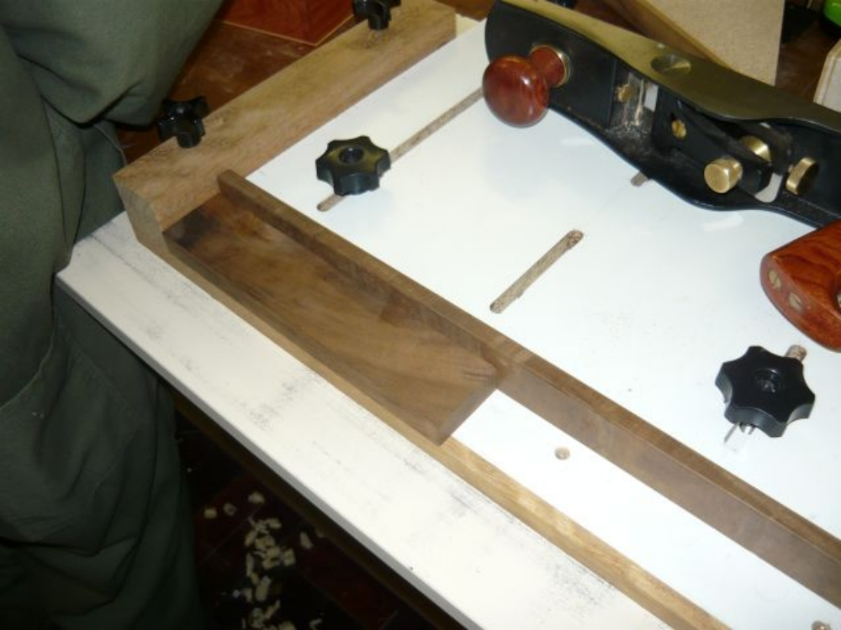

Part of my multipurpose shooting board. (I'm left handed, so the plane runs on the left side of the jig, on its side.) The workpiece here is being held by the second part of the jig, which holds a piece of work lengthways in order to straighten and flatten an edge of a board at 90 degrees to the (horizontal) flat face. It is very useful in dealing with small pieces of wood, too small to run over a planer. It also enables precise sizing of several small pieces - simply plane until the plane no longer makes contact, then do the same with the next piece.
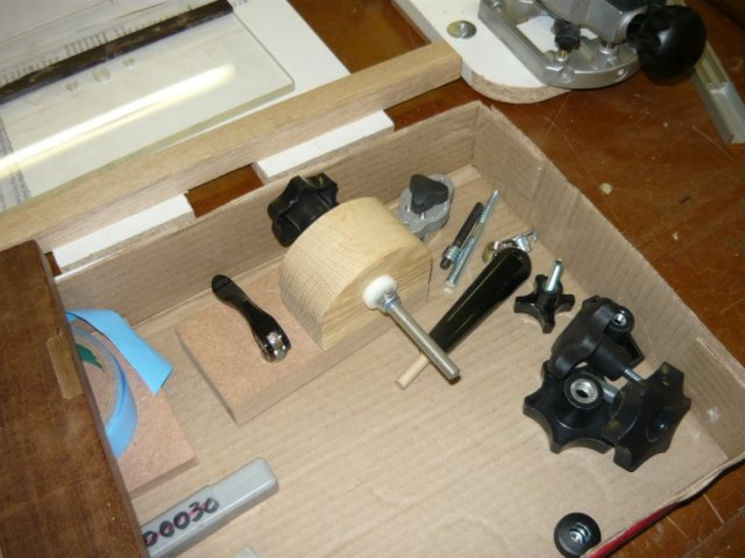

A variety of handles and knobs available, a Magjig switch (in the top corner of the box), insert nuts (or woodserts), etc. Above the box is a hinge mortising jig. (It is upside down - melamine chipboard with wood registration bar).
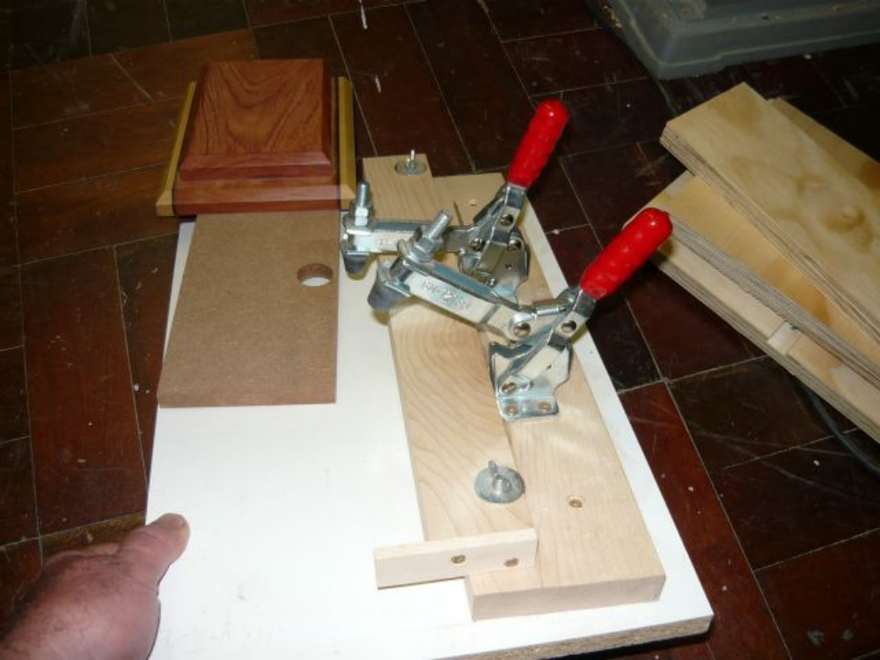

A jig made to register the two parts of the uprights on my sliding dovetail bookcases
for gluing. In the background is a completed upright. The piece on top needed to be accurately
lined up with the bottom section, and held in place while the glue dried. The two toggle clamps
closed down, drawing the two parts tightly against the fence. (The clamps went through holes
in the MDF in the middle of the picture (one hole is covered in the photo) and the MDF then
provided a surface for attaching more clamps without marring the work. The two parts of the
upright registered against the fence and up against the registration bar in the foreground.

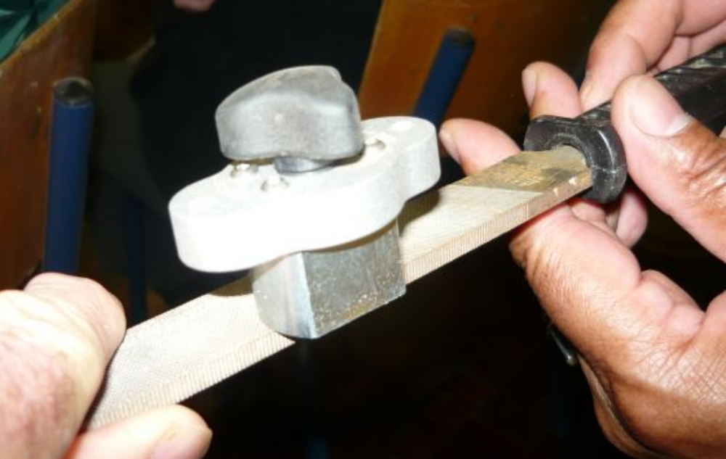

The Magjig switch. This uses rare earth magnets - when you turn the switch it alters the
polarity positioning, either turning the magnets on or off. They have amazing holding force.
The smaller version (shown here) has a clamping force of 80 pounds, while the bigger one doubles this.
They are used to hold jigs such as featherboards in place on tablesaws, etc - easy to set in place,
and very firm when turned on.

