Vintage Car

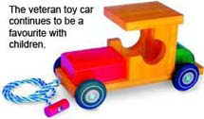

Old-fashioned wooden toys have had perennial appeal to young and old alike, but the simple wooden toy car has always been a timeless favourite.
Long after the racing cars, the plastic boats and the metal robots have lost their charm the little pull-along, wooden toy car will still be enjoyed.
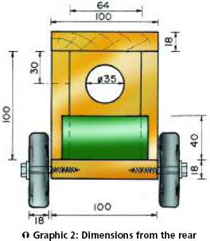
Simply follow these step-by-step instructions to make a veteran car for your children or grandchildren.
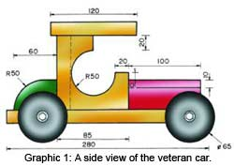

Preparation
• Mark out the two sides according to graphic 2 and then cut them out with a band saw.
• Use a 4,8mm rounding over cutter to trim the inside edges.
• Cut away the two top edges of the engine to create a 45° angle.
• Cut away the rounding of the boot.
• Drill a 25mm hole in the rear of the cab, using a 25mm flat drill bit. • Clamp the engine onto the drill press worktable and use a 20mm spade bit to drill two lengths to a depth of 3mm (see graphic 4).
Assembly
• Apply glue to the cab's rear sides and fix the sides using two panel pins per side.
• Apply glue to the base of the sides that you have just joined and then use at least five panel pins to fix them to the base.
• Repeat this procedure for the cab roof.
• Wipe away any excess glue with a damp cloth and then allow the glue to dry.
• Apply wood filler where necessary and let it dry.
• Sand the car to a very smooth finish.
• Apply two coats of sanding sealer and sand lightly between coats, using 150-grit sandpaper.
• Paint the veteran car with brightly coloured, non-toxic paint.
• Allow the paint enough time to dry properly.
• Repeat this process with the engine and the boot. When these pieces are dry, place them into position and affix them with panel pins or 30mm no 6 pozi-drive screws.
• Paint the recess lights with aluminium or silver paint.
Tools
• Band saw
• Pencil
• Router
• 4,8mm rounding over router bit
• Drill press
• Adjustable circle cutter
• 25mm flat drill bit
• 20mm spade bit
• 4mm drill bit
• Clamps
• A clean cloth
Making the wheels
• Use a pencil to mark the 350mm x 80mm piece of Supawood into four equal squares of 80mm x 80mm.
• Now mark the centre of each square where the axle hole will be drilled.
• Insert a 16mm spade bit into the drill press and drill each wheel to a depth of just 3mm, ensuring that the point of the spade bit enters exactly on the centre mark.

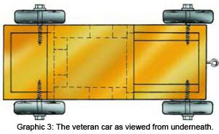
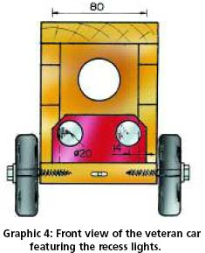

• Insert an adjustable circle cutter into the drill press and adjust its setting to the exact radius of 32,5mm. It is important to ensure that the long edge is pointing inwards so that the bevelled scrap is not left on the edge of the wheel.
• Clamp the Supawood onto a wooden face on the drill worktable. You may need to adjust the wood so that the pilot bit of the cutter is exactly in line with the pilot hole made by the spade bit.
• Set the drill press to a slow speed and carefully cut all four wheels to a depth of about 12mm - do not try to lower the cutter too quickly.
• Turn the Supawood over, adjust the pilot bit of the cutter to fit the pilot hole, clamp it in position and cut the rest of the way through.
• Sand the wheels to a smooth finish. Pay special attention to the outer edges.
• Apply one or two coats of non-toxic black paint and allow the wheels to dry.
Affixing the wheels
• Drill two pilot holes to a depth of 40mm in both sides of the base, using a 4mm drill bit. Before you start drilling, make sure that these holes are 20mm from the front and 40mm from the rear of the base.
• Use coach screws to fix the wheels into place.
• Insert a no 6 eyehook into the front of the engine and then attach a towrope.

Materials
• Base: 1 x 18mm x 280mm x 100mm SA Pine
• Roof: 1 x 18mm x 120mm x 100mm SA Pine
• Rear of the cab: 1 x 18mm x 100mm x 64mm SA Pine
• Cab sides: 2 x 18mm x 100mm x 85mm SA Pine
• Engine: 1 x 100mm x 80mm x 40mm SA Pine
• Rear boot: 1 x 80mm x 60mm x 40mm SA Pine
• Four wheels: 1 x 18mm x 80mm x 350mm Supawood
• 4 x 60mm M6 coach screws
• 4 x M6 washers
• 1 x no 6 eye hook
• 30mm panel pins
• Cold glue
• 150-grit sandpaper
• Wood filler
• Sanding sealer
• Black & brightly-coloured non-toxic paints
• Aluminium or silver paint for the recess lights

